BUCKET LIST PROJECT
What is a bucket list? A bucket list is a list of goals that you want to accomplish throughout your lifetime. For this project, you must choose…
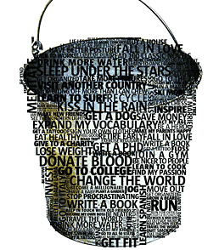
- 30 items minimum to be included on your bucket list
  - 6 personal items: Think: health/love/community/personal development. Do you want to learn to do 30 push-ups? Do you want a family? Do you want to volunteer? Do you want to become less shy?
  - 6 academic/career items: What do you want to achieve in terms of academics? Do you want to attend college/university? What kind of job do you want in the future?
  - 6 activities/skills/hobbies: Do you want to learn a new language? Do you want to learn to play chess? Do you want to learn to skate?
  - 6 adventures/experiences: Do you want to travel to Japan? Do you want to try sky diving?
  - 6 free choices: Six other items that come from any of the above categories
After you have made your list of 30 items, you must choose 5 items from your list [1 from each category and 1 of your choosing] and write a paragraph to explain why you chose this item and any additional details that might be pertinent such as how/when you think you’ll accomplish this goal.
You must present your list in a creative way and included different images to go along with the items on your list. Please be sure to edit your list!

Bucket List Rubric
- Did you follow the format requirements? [30 items minimum to be included on your bucket list]
5 4 3 2 1 0
- In-depth explanation of 5 items [1 from each category, 1 of your choosing]
5 4 3 2 1 0
- Did you include interesting information presented in a creative format?
5 4 3 2 1 0
- Do you have detailed, attractive visuals to accompany your bucket list?
5 4 3 2 1 0
- Is your bucket list edited?
5 4 3 2 1 0
Total: ________ / 25 points

